|  |
| --- |
| KP GAMES |
| Captain Claw Jump |
| 2D Platformer Assignment |
| Version #1.0  All work Copyright © 2016 by KP Games.  All rights reserved. |
| **KHILAN PATEL - 300785048** |
|  |

|  |
| --- |
| February 29th 2016 |

Table of Contents

Update History 3

Game Overview 4

Game Play Mechanics 4

Camera 4

Controls 4

Interface Sketch 4

Menu and Screen Descriptions 5

Game World 6

Levels 6

Characters 6

Enemies 6

Items 6

Scoring 6

Sound Index 7

Multimedia index 7

Future Features 8

# Update History

Github link: <https://github.com/Khilan/Assignment2_PlatformGame>

|  |  |  |
| --- | --- | --- |
| Commits | Description | Dates |
| Update 0.01 | Initial Commit | (Feb 26, 2016) |
| Update 0.1 | Added Hero Animation | (Feb 26, 2016) |
| Update 0.2 | Added Ground check and some other functionality | (Feb 27, 2016) |
| Update 0.3 | Camera is moving with Hero | (Feb 27,2016) |
| Update 0.4 | Add Labels and Death Platform | (Feb 27, 2016) |
| Update 0.5 | Added sound and more functionality | (Feb 27, 2016) |
| Update 1.0 | Final Commit of the game | (Feb 29, 2016) |

1. **Game Overview**

*This game is about the Captain claw(Rat) who is in jungle. The player will get points based on the collecting diamonds. Player has to avoid the hurdles in order to survive.*

1. **Game Play Mechanics**

*Player will get 10 points for 1 diamond. Player has 5 chances to get survive. If player hit with hurdles or fall from the platform then the lives will reduce. When player losses 5 lives, game will over and player will be asked to restart the game.*

1. **Camera**

The camera is player centric and it moves along with the player.

1. **Controls**

*Player can use WASD and standard arrow keys to move.*

1. **Interface Sketch**

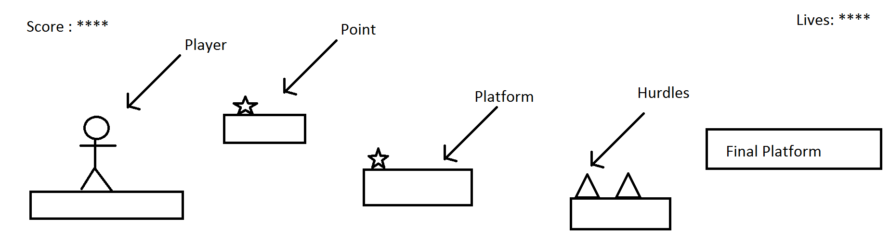

1. **Menu and Screen Descriptions**

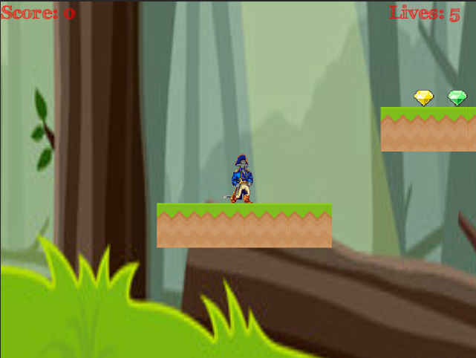

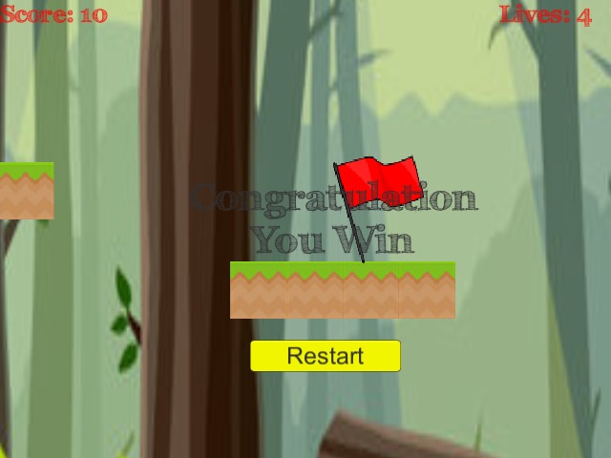

*Screen of the game shows the Scoreboard and Lives board. After end of the game it will display the High Score and Restart button to restart the game.*

1. **Game World**

*Game world is about the jungle where Rat is jumping from one platform to another and it has all kinds of hurdles and diamonds.*

1. **Levels**

The game doesn’t have any levels but it has checkpoints, so when player die at a certain point he might continue from same or nearby point if he has crossed the checkpoint.

1. **Characters**

|  |  |
| --- | --- |
| Player | **D:\Unity Project\Ass2-platform\Assets\Sprites\Hero\0.png** |

1. **Enemies**

*There is enemy like spikes which cause damage when player collides or hit with them.*

1. **Items**

|  |  |
| --- | --- |
| **Spikes** | **D:\Unity Project\Ass2-platform\Assets\Sprites\obstacles.png** |

1. **Scoring**

*When player get one diamond then player will get 10 points and when player crash will enemy then player loss 1 live.*

1. **Sound Index**

*The games has following sounds.*

*Jump – When Player jump on platform*

*Hurt – When Player hit with enemy*

*Ting – When Player get diamonds*

1. **Multimedia index**

|  |  |
| --- | --- |
| Hero Sprite | **C:\Users\Khilan\Desktop\rat.png** |
| Background | **D:\Unity Project\Ass2-platform\Assets\Sprites\game.jpg** |
| Environment tileset | **D:\Unity Project\Ass2-platform\Assets\Sprites\tiles\222.png D:\Unity Project\Ass2-platform\Assets\Sprites\tiles\111.png D:\Unity Project\Ass2-platform\Assets\Sprites\Diamond\4.png D:\Unity Project\Ass2-platform\Assets\Sprites\Diamond\3.pngD:\Unity Project\Ass2-platform\Assets\Sprites\Diamond\2.png D:\Unity Project\Ass2-platform\Assets\Sprites\Diamond\1.png D:\Unity Project\Ass2-platform\Assets\Sprites\Diamond\0.png D:\Unity Project\Ass2-platform\Assets\Sprites\Diamond\5.png D:\Unity Project\Ass2-platform\Assets\Sprites\obstacles.png** |

1. **Future Features**

*The Future features may include:*

1. *Weapons*
2. *Levels*
3. *Enemy*
4. *Health booster*